



# Applied Physics for Scientists and Engineers

**Lab Report 2: Conversion of Galvanometer into** Voltmeter

**Submitted to**

Sir. Haseen Ullah Jan

**Submitted by**

Muhammad Sadeeq

ETEA ID. 75025

Sec. C Computer

Systems Engineering Fall 2021



**Conversion into Voltmeter:**

**Apparatus:**

1. Galvanometer
2. DC E.M.F source
3. High resistance box
4. Low resistance box
5. Key switches
6. Rheostat
7. Connecting Wires
8. Voltmeter

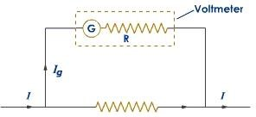

**Procedure:**

1. Find the resistance of the galvanometer by half scale deflection method.
2. Measure the voltage by battery or cell by voltmeter.

6. To measure Rg, the high resistance R, galvanometer, Key K and battery should be connected in series.

Plug the key K and adjust the resistance of H.R.B., to get the full scale deflection of galvanometer.

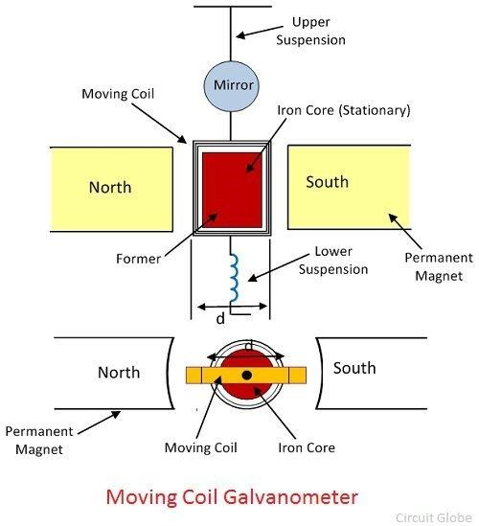

**Calculation:**

Let the full scale deflection be the current of

Ig. From Ohm’s Law, V=Vg+Vh.r.b

V=IgRg+IgR

E=Ig(R+Rg)

Ig=E/R+Rg

For calculating value of R(H.R.B.)

Ig=E/R+Rg

R=E/Ig - Rg

|  |  |  |  |  |  |
| --- | --- | --- | --- | --- | --- |
| S.N  o. | R | Readings of converted voltmeter in (ፀ) | Reading of converted | Reading of standard | Difference  V-V’ |
| 1 | 20 | 10 | voltmeter (v’)  3/30 x 10= 1V | voltmeter(V)  0.8 V | 1-0.8=0.2V |
| 2 | 40 | 12 | 3/30 x 10 = 1.2V | 1.1 V | 1.2-1.1=0.1V |
| 3 | 50 | 11 | 3/30 x 11= 1.1 V | 0.9 V | 1.1-0.9=0.2 V |
| 4 | 100 | 14 | 3/10 x 14 = 1.4 V | 1.1 V | 1.4-1.1=0.3 V |

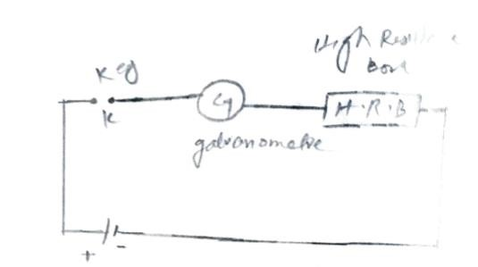

**Precautions:**

1. Connections should be clean.
2. Voltage of the E.M.F. source should be constant during the experiment.
3. Error of galvanometer and voltmeter should be removed.

7. The terminal of battery should be connected to the positive terminal of battery.